**DAILY ONLINE ACTIVITIES SUMMARY**

|  |  |  |  |  |  |  |  |  |
| --- | --- | --- | --- | --- | --- | --- | --- | --- |
| **Date:** | **29/5/2020** | | | | | **Name:** | **Banish M G** | |
| **Sem & Sec** | **8th Sem** | | | | | **USN:** | **4AL16CS020** | |
| **Online Test Summary** | | | | | | | | |
| **Subject** | | **BDA** | | | | | | |
| **Max. Marks** | | **30** | | **Score** | | | **24** | |
| **Certification Course Summary** | | | | | | | | |
| **Course** | **Udemy: Python for Data science and Machine Learning** | | | | | | | |
| **Certificate Provider** | | | **Udemy** | | **Duration** | | | **4 hrs** |
| **Coding Challenges** | | | | | | | | |
| **Problem Statement:**  1.   Write a C Program to generate first N Armstrong Numbers | | | | | | | | |
| **Status:COMPLETED** | | | | | | | | |
| **Uploaded the report in Github** | | | | | **yes** | | | |
| **If yes Repository name** | | | | | B**anish_MG** | | | |
| **Uploaded the report in slack** | | | | | **yes** | | | |

Online Test Details: (Attach the snapshot and briefly write the report for the same)

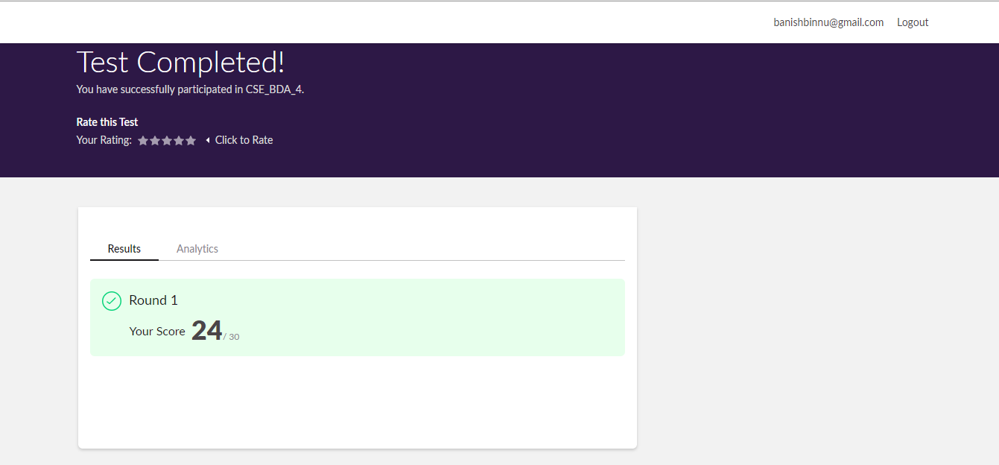

Certification Course Details: (Attach the snapshot and briefly write the report for the same)

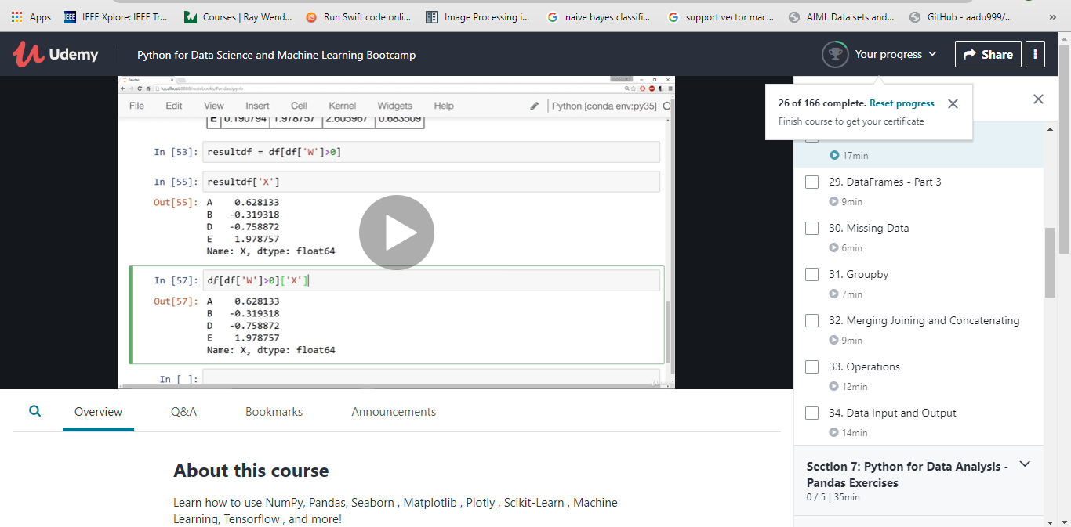

Coding Challenges Details: (Attach the snapshot and briefly write the report for the same)

 Write a C Program to generate first N Armstrong Numbers

#include<stdio.h>

#include<conio.h>

main()

{

int r;

long no = 0, c, res = 0, a;

printf("Enter the maximum range upto which you want to find armstrong numbers ");

scanf("%ld",&no);

printf("Following armstrong numbers are found from 1 to %ld\n",number);

for( c = 1 ; c <= no; c++ )

{

a= c;

while( a != 0 )

{

r = a%10;

res = res+ r*r*r;

a = a/10;

}

if ( c == res )

printf("%ld\n", c);

res = 0;

}

getch();

return 0;

}